 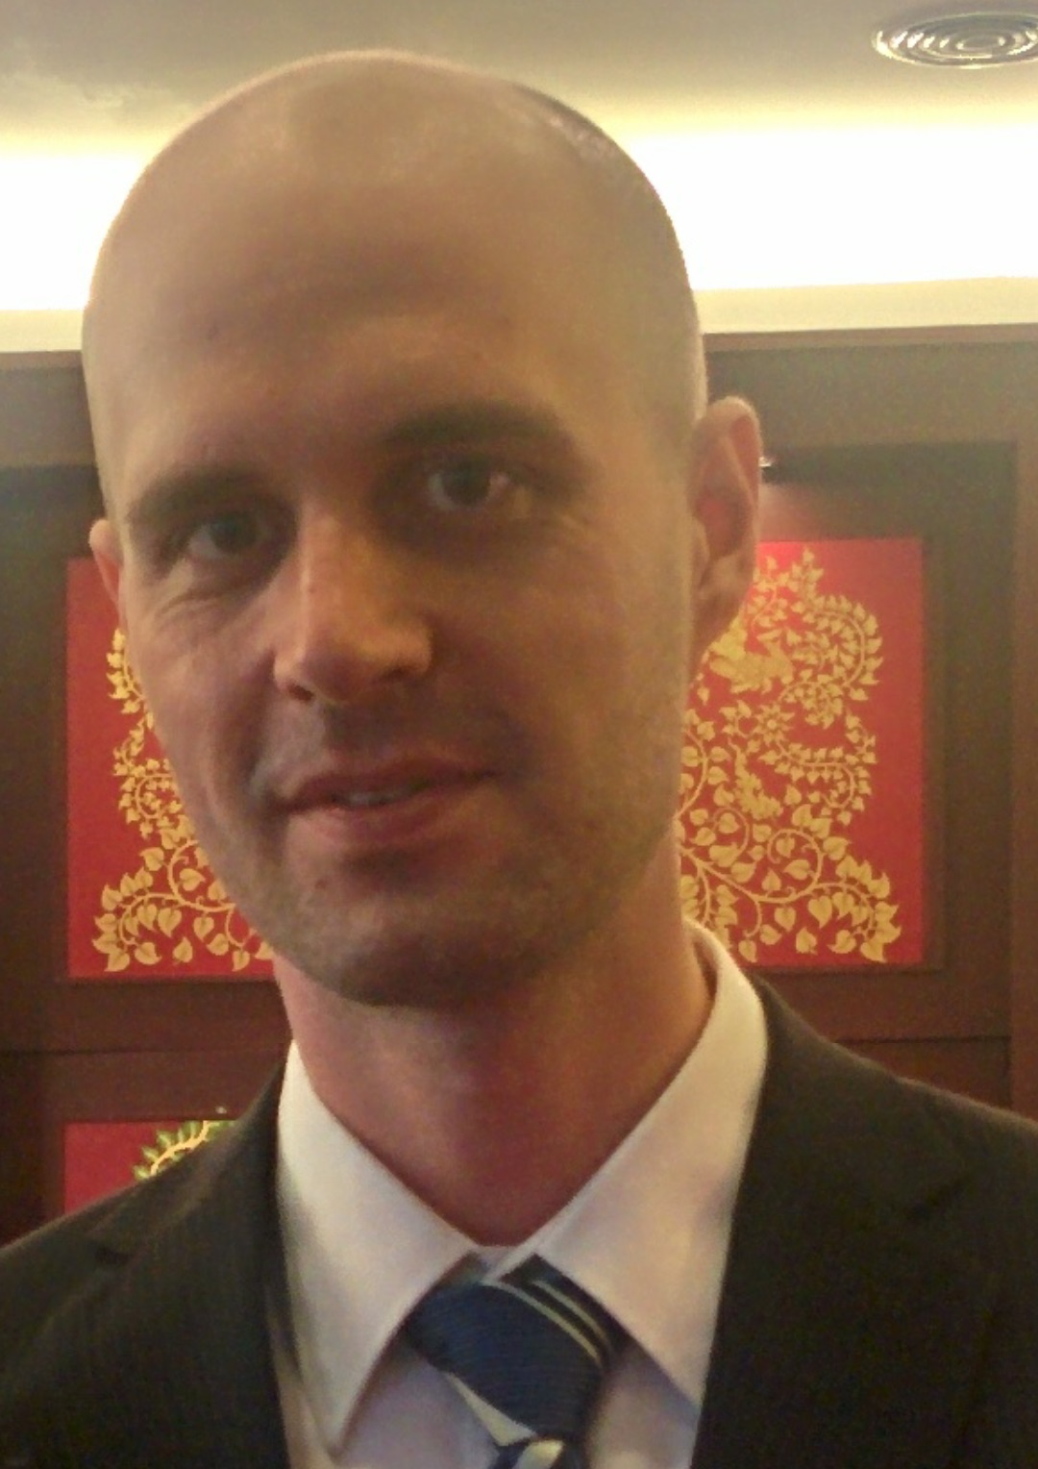

 WHY IN BANGKOK?

Three years ago, picturing Hong Kong as the main goal after Australia, I had a four day stopover in Bangkok. The liveliness, joyfulness and the feeling of that an opportunity is behind every corner immediately changed my mind. Instead, Bangkok became the new destination of choice in order to finish my studies and settle down.

 SKILLS

● Word ● Wordpress

● Excel ● Marketing Strategy

● PowerPoint ● Business Development

● Salesforce ● Sales Management

● Prezi ● Cultural Awareness

What I can offer you and your company are new ideas in sales, management, business development and marketing with an urge to learn more and succeed within the department while streamlining current routines. My goal is to combine my experience in account management and business development with my skills in marketing strategies and management, and I am sure that I can deliver satisfactory results.

These facts in conjunction with my academic records, I know that I am an suitable applicant. I have always demonstrated good results in previous work places, both in terms of sales, customer satisfaction and internal satisfaction in relation to each follow-up.

In conjunction with this, I have always reached the set targets and budgets while I have provided customers with the desired products to meet their needs while working in diverse teams. Although, several tasks have been performed by myself individually, both options with great outcomes.

 WHY ME?

 LANGUAGES

Thai

English

Swedish

 https://th.linkedin.com/pub/mikael-karlsson/56/b11/2a6

 (+66) 094 981 1291

 mikael85karlsson@gmail.com

CONTACTS

**INSURANCE BROKER**

Guidance and sales of the company wide range of insurances to private consumers depending on the specific customer’s demand.

 Stockholm

At Länsförsäkringar Stockholm

**ACCOUNT MANAGER**

Account manager with Telia Sonera as taskmasters, due to good results in previous assignments, providing a full range of products to medium size corporate customers.

 Stockholm

At Teleperformance Nordic

2005 - 2006

2009 - 2011

2006 - 2007

2007 - 2009

 EDUCATION

**FINANCIAL ADVICING**

Guidance and sales with the mission to provide the best financial advice to private customers through putting together the best solution using various financial instruments.

 Stockholm

At Länsförsäkringar Stockholm

At Teleperformance Nordic

 Stockholm

Start-up project with the objective to increase sales for an external client, which was accomplished through PERT and CPM in a handpicked team of high performance employees making decisions regarding everything from commission regulations to CRM system features.

**PROJECT DEVELOPER**

Bangkok



 Perth

 Perth

At Perth Institute of Business and Technology

**Diploma of Business**

Business 101 units, GPA: 71.

2011 - 2012

2014 - 2015

2012 - 2013

At Bangkok University

At Edith Cowan University

WORK EXPERIENCE



B.B.A., M.B.A.

Master thesis in motivational managent, GPA: 3.80.

**Master of Business Administration**

Double major in marketing and international business, GPA: 72.

**Bachelor of Business**

MIKAEL

**KARLSSON**